**LEVANTE SUPER ASSEMBLING INSTRUCTION**

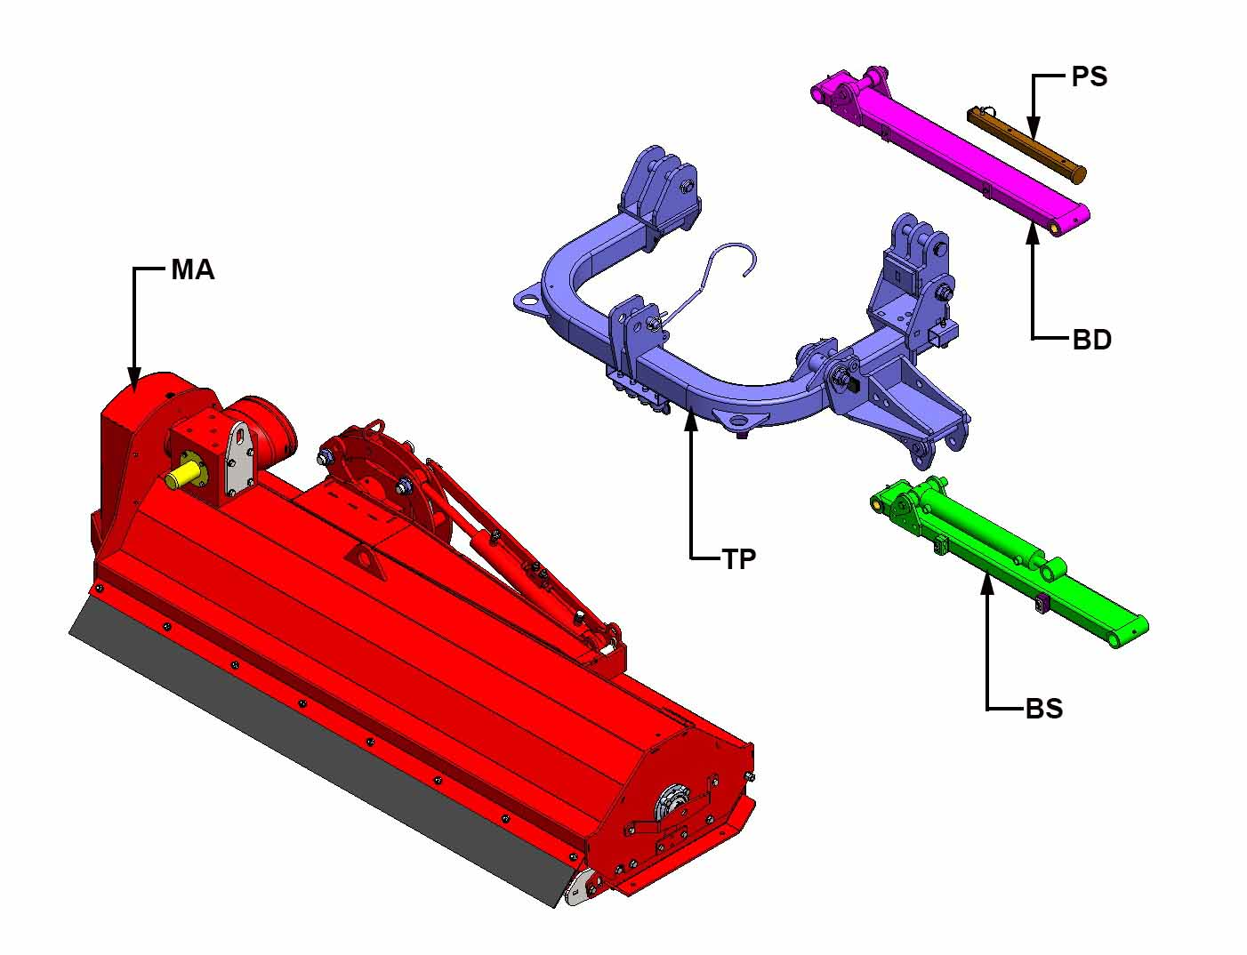

Remove from the packaging all the components of the machine, the machine body "MA", the attachment "TP", the left arm "BS" complete with hydraulic cylinder, the right arm "BD" and the parking foot "PS" complete with stationary pin.

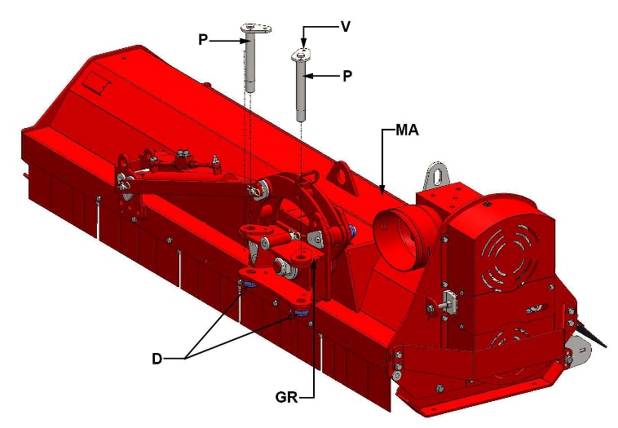

From the rotation group "GR" of the machine body "MA" unscrew the two nuts "D", unscrew the two "V" retainers and then pull out the two pins "P".

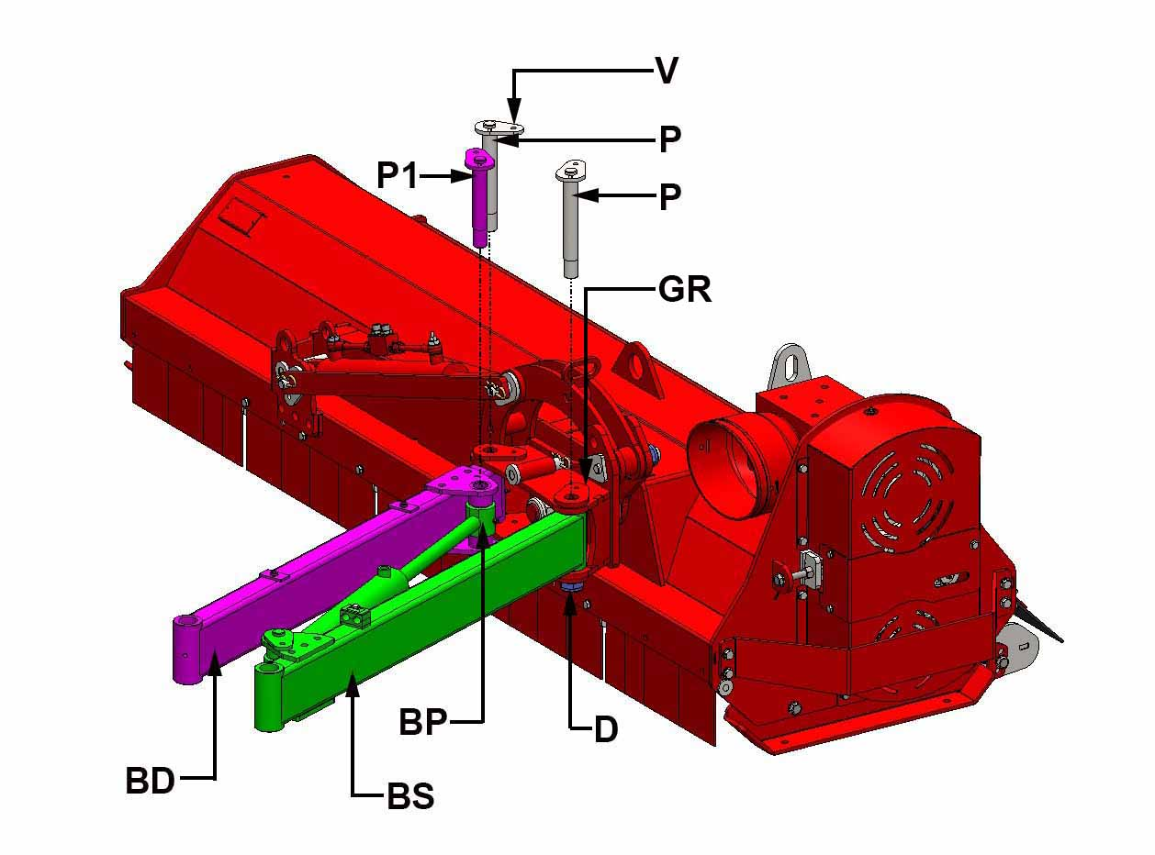

Unscrew the nut "D" and the screw "V" from the pin "P1" and then pull it out of the arm "BD". Insert the left arm "BS" and the right arm "BD" into the "GR" rotation group locations, and then insert the two pins "P". Insert the "BP" hydraulic cylinder bushing into the right arm “BD” seat and then insert the pin "P1". Screw the three "V" retainers of the "P" and "P1" pins and then screw the three self-locking nuts "D".

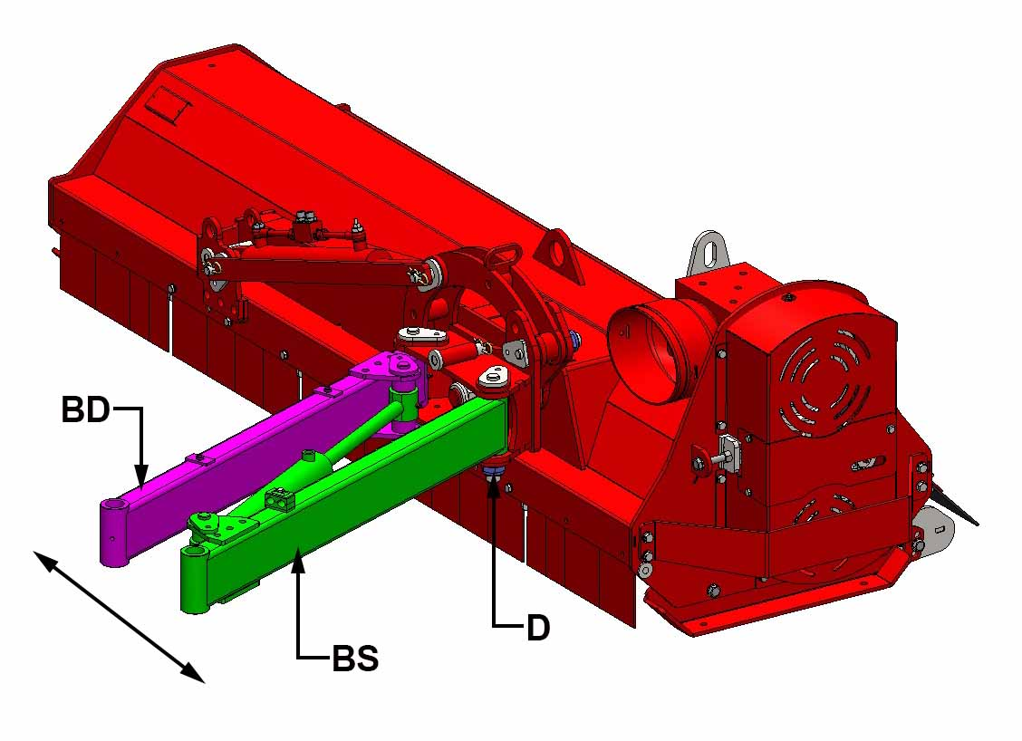

Make sure that the "BS" and "BD" arms can move freely left and right, if they are too stuck loosen the "D" nuts by half a turn.

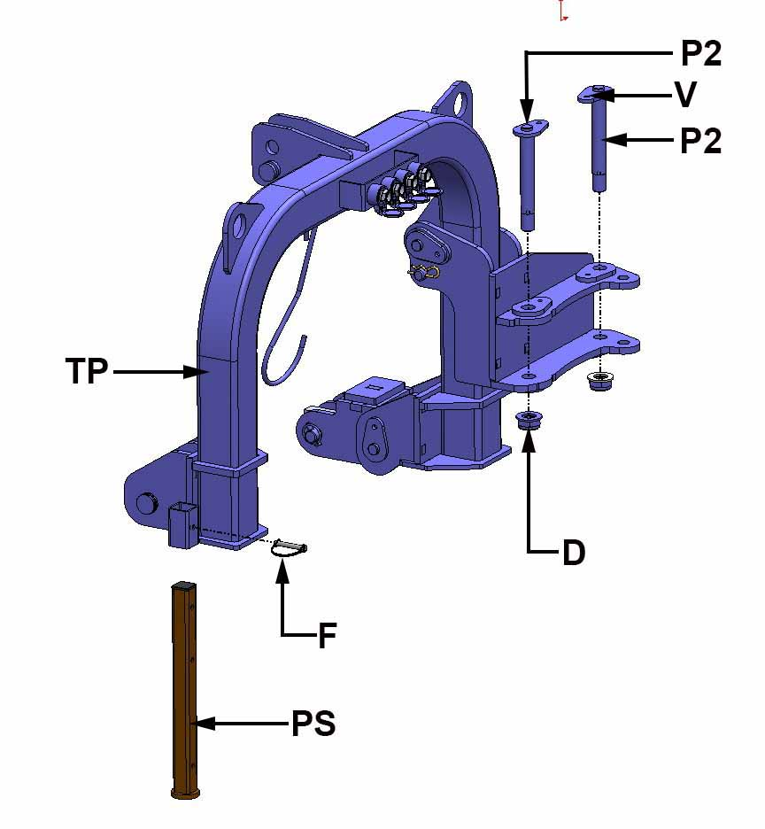

Unscrew the "D" nut and the "V" retainer screw of the two pins "P2" and then pull them out of the "TP" attachment, insert the "PS" parking foot in its seat and lock it with the "F" retaining pin.

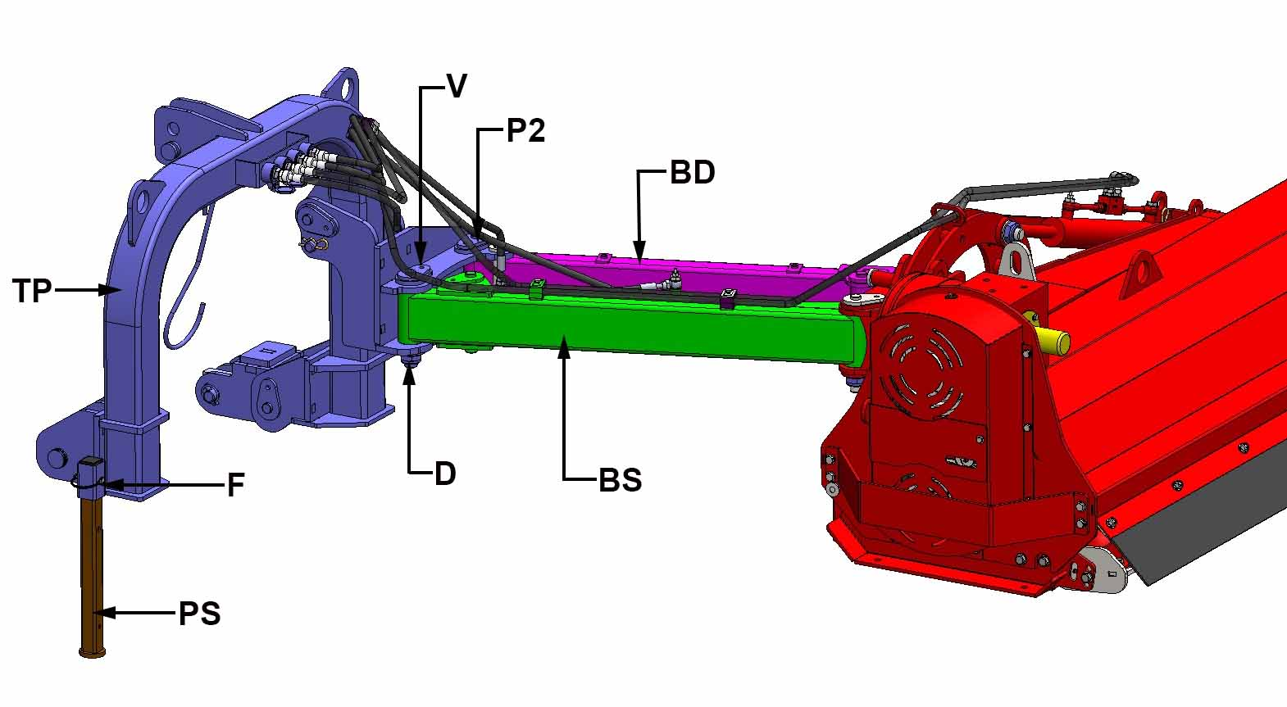

Insert the "BS" and "BD" arms into the "TP" attachment locations, and then insert the two pins P2. Screw the two "V" retainers of the "P2" pins and then screw the two self-locking nuts "D" thoroughly. Unscrew the two "D" nuts by 1/2 turn to ensure proper rotation of the "BS" and "BD" arms. Lock the hydraulic hoses of the two cylinders to the arms and the attachment using the supplied latches.

**FIRST START**

**ATTENTION**: the machine must be connected to an agricultural tractor with power between 80 and 120 HP, with 4 hydraulic connections on the back.

1. Attach the machine to the tractor as follows:
2. Remove the spring pins from the two lower connection pins.
3. Insert the lifting arms of the tractor in the lower pins and then block them with the safety spring pins. Alternatively, if the lifting arms of the tractor are equipped with quick coupling, mount the ball joints on the lower pins, lock the pins with the safety spring pins then activate the lifter to hook the machine.
4. Connect the 3-point hitch of the tractor to the 3-point hitch of the machine (the apex) with the corresponding tie-rod, insert the pin and lock with the spring pin.
5. Connect the 4 hydraulic tubes to the quick coupling system of the tractor.
6. Pull out the two safety pins and then remove the block bar "A".
7. Make sure that rotation blocking pin "B" is positioned as shown in Picture 1. Once the security pin has been removed, remove the side-shift blocking pin "C" as well and place it in the slot "C1".
8. Connect the PTO of the tractor to the cardan shaft of the machine. Verify that the security chains are fixed to prevent the cover of the cardan shaft protection from rotating.
9. Start the engine of the tractor, lift the machine from the ground, start the tractor PTO then side-shift and rotate the machine repeatedly to eliminate air from the hydraulic system.

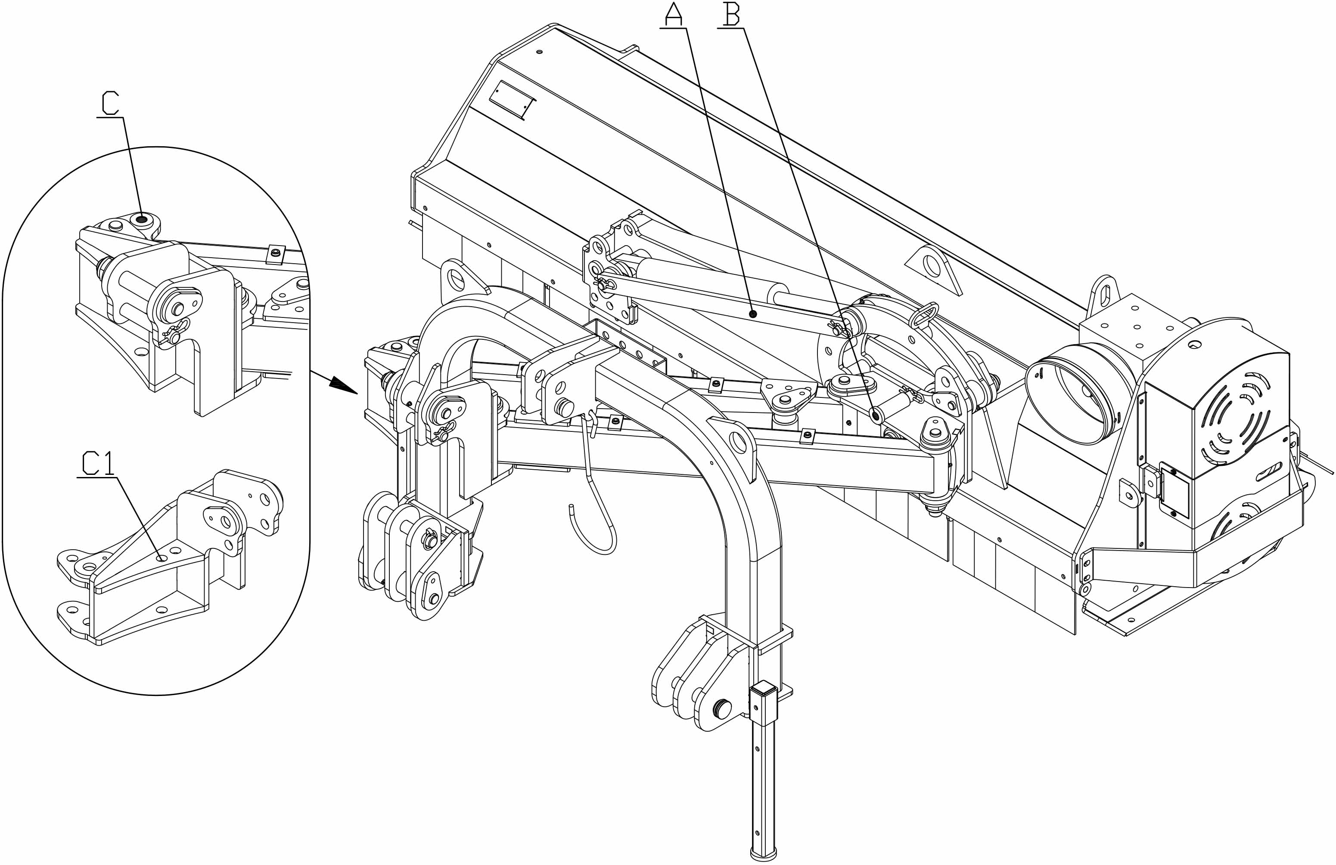

According to the needs of the customer, it is possible to adjust the speed of the hydraulic cylinder of both the side-shifting and rotating system, with the regulator mounted on the connection between the hydraulic tube and the bottom plate of each cylinder.

After eliminating the air from the hydraulic system, rotate the machine upwards and downwards. If you need to adjust the speed of the movement, after unscrewing the locking nut "D", rotate the screw "V" clockwise to decrease or anticlockwise to increase the speed. Repeat the procedure until reaching the desired speed, then block the screw "V" tightening the blocking nut "D".

Repeat the same procedure to regulate the speed of the side-shift cylinder.

